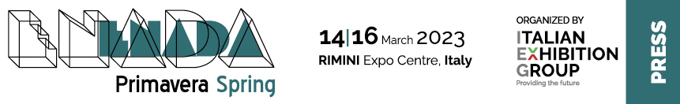

press release

GAMING AND BETTING ON THE UPTURN

Italians spent 19.6 billion euros on gambling in 2022

Rimini, 8th March 2023 - After the long 2020-2021 closure, betting and bingo halls in Italy have resumed normal activity. And, according to initial estimates, the recovery is continuing.
One fact for all: Italians spent EUR 19.6 billion on gaming in 2022 (in other words, total takings minus winnings): up +28% compared to 2021 (EUR 15.4 billion) and even 2% more compared to 2019 (EUR 19.3 billion).
The Treasury will receive EUR 10.3 billion, down -9% compared to 2019 (EUR 11.3 billion), but up +22% compared to 2021.
Spending on online gaming is also on the rise, going from 1.8 billion in 2019 to 3.7 billion last year.
Overall, the final figures of 2021 showed takings for physical gaming at EUR 44 billion, 910 thousand compared to EUR 39 billion, 48 million in 2020 and EUR 74 billion, 75 million in 2019. Winnings went from EUR 56.5 billion in 2019 to EUR 28.7 billion in 2020 and EUR 32.2 billion in 2021, while expenditure (i.e., total takings minus winnings) dropped from EUR 17.5 billion in 2019 to EUR 10.3 billion in 2020 to then grow to EUR 11.8 billion in 2021, all reflecting the strong impact of the pandemic and the consequent closure of gaming venues on physical betting.
As for the different types of physical games in 2021, automated gaming machines stood in first place with takings of 18.2 billion, followed by lotteries with 12.05 billion, Lotto with 8.1 billion and sports-based games with 2.05 billion.
The region with the most gambling in 2021 was Lombardy with 8.5 billion, followed by Campania with 4.7 and Lazio with 4.4 billion. At the tail end was Valle d'Aosta with just over 53 million euros.

Sources: ADM - Agenzia Dogane e Monopoli (Customs and Monopolies Agency) / SAPAR / AGIMEG

PRESS CONTACT media@iegexpo.it
head of corporate communication & media relation: Elisabetta Vitali; press office manager: Marco Forcellini; international press office coordinator: Silvia Giorgi

This press release contains forecast elements and estimates that reflect the management’s current opinions (“forward-looking statements”), particularly regarding future management performance, realization of investments, cash flow trends and the evolution of the financial structure. For their very nature, forward-looking statements have a component of risk and uncertainty, as they depend on the occurrence of future events. The effective results may differ (even significantly) from those announced, due to numerous factors, including, only by way of example: food service market and tourist flow trends in Italy, gold and jewellery market trends, green economy market trends; the evolution of raw material prices; general macroeconomic conditions; geopolitical factors and evolutions in the legislative framework. Moreover, the information contained in this release, does not claim to be complete, and has not been verified by independent third parties. Forecasts, estimates and objectives contained herein are based on the information available to the Company as at the date of this release.

